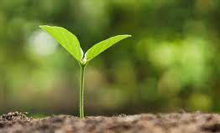
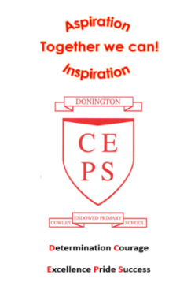
Keen to be
Green!

Year 1 and Year 2  Summer Term 2022 | English  In English, we will be improving our grammar, language and ability to write for different purposes through our topic. Some of the exciting writing opportunities this term include looking at thematic poetry and instructions. We will be writing letters inspired on local and global environmental issues from the book Dear Greenpeace by Simon James.  We will have the opportunity to find out more about Quentin Blake in an author study.  Reading for pleasure and enjoyment will lie at the heart of our English curriculum. Children will be involved in using a wide range of texts, linked to topic. They will take part in group discussions and will be encouraged to share their own views and reading interests. Through discussion and questioning comprehension skills will be developed, enabling children to increase understanding and appreciation of literature. Opportunities within all areas of the curriculum will be made available for children to develop their spoken language through discussion, drama and presentations.
More about our topic…
This is an incredibly fascinating topic and we aim to make it a memorable one! Through cross-curricular learning we will partake in some exciting activities, including developing our art skills, through using recycled materials.
We will also be finding out about the causes and effects of climate change around the world.
Pupils will learn about seasons and weather patterns, pollution and how they can help to care for the environment.
Pupils will extend their geographical knowledge of the world’s seven continents and five oceans. They will be using world maps, atlases and globes to identify hot and cold areas of the world. Children will learn to use basic geographical vocabulary to refer to human and physical features.
As well as this, our study will include the human impact on the environment and how we can look after our planet.
Make sure you continue to keep an eye on our web page and class blog to see the fantastic learning taking place!

Maths
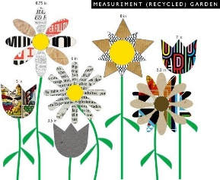
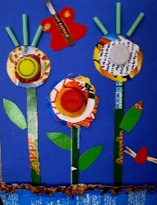
Maths will be taught as an individual subject and will continue to adhere to the curriculum objectives. Teaching will enable children to become fluent in arithmetic as well as being able to reason and problem solve. Maths lessons will cover all aspects including, understanding number, using all four operations, measurement, geometry and statistics. Pupils will be extended at every opportunity to ensure their potential as mathematicians is achieved.
Take home task to support work in school
To prepare for our new topic, it would be brilliant if the children could make an A4
collage of a garden scene using a variety of recycled materials such as
labels, packets, bottle tops.

Thank you for your continued support.

