***Maths***

*Maths will be taught as an individual subject and will continue to adhere to the curriculum objectives. Teaching will enable children to become fluent in arithmetic as well as being able to reason and problem solve. Maths lessons will cover all aspects including, understanding number, using all four operations, measurement, geometry, and statistics. Pupils will be extended at every opportunity to ensure their potential as mathematicians is achieved. We shall of course also be practising for our SATs maths tests up until May.*

***Take home task to support work in school****To prepare for our new topic, it would be brilliant if the children could find some fascinating facts about recent (21st Century) natural disasters. These can be presented in a medium of their choice – a model would be especially good! They will need to be prepared to present and talk about their work to the rest of the class.*

*Elm and Oak Class*

*Summer Term 2022*

***English***

*We shall be practising for our SATs up until May. After that, our new class text for the summer term will be Running Wild by Michael Morpurgo. It is about a young boy caught up in the Tsunami which struck the South East Asian coast on Boxing Day, 2005.*

*Reading for pleasure and enjoyment will lie at the heart of our English curriculum. Children will be involved in guided reading, using a wide range of texts, linked to topic. They will take part in group discussions and will be encouraged to share their own views and reading interests. Through discussion and questioning comprehension skills will be developed, enabling children to increase understanding and appreciation of literature.*

*Children will have the opportunity to find out more about Michael Morpurgo in an author study as well as use their writing skills to write explanation texts and reports to support our geography work.*

*Opportunities within all areas of the curriculum will be made available for children to develop their spoken language through discussion, drama, and presentations.*

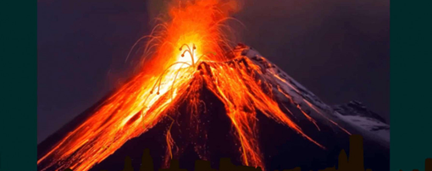

*Forces of Nature*

***More about our topic…***

*This is an incredibly fascinating topic, and we aim to make it a memorable one! Through cross-curricular learning we will partake in some exciting activities, including developing our art skills, through the Japanese artist Hokusai’s painting of ‘The Wave’.*

*We shall be finding about natural disasters in the world and what causes them. We shall focus on the earthquakes, volcanoes, and tsunamis of recent times as well as the historical ones such as Pompeii.*

*We shall learn about how volcanoes are formed and what causes earthquakes and tsunamis. We shall investigate ways in which scientists can gauge or predict an impending disaster.*

*In addition to this, we shall be looking at how we can prevent natural disasters from happening. We shall especially focus on the effect of climate change and consider ways in which it can be curbed. We will also look at what we can do to prevent the destruction of our planet.*

*Make sure you continue to keep an eye on our web page to see the fantastic learning taking place!*