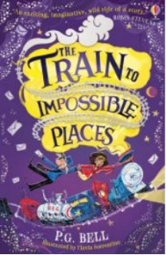
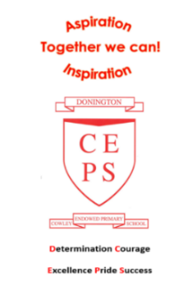
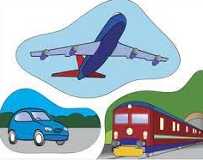
Maths
Maths will be taught as an individual subject and will continue to adhere to the curriculum objectives. Teaching will enable children to become fluent in arithmetic as well as being able to reason and problem solve. Maths lessons will cover all aspects including, understanding number, using all four operations, measurement, fractions and statistics. Pupils will be extended at every opportunity to ensure their potential as mathematicians is achieved. 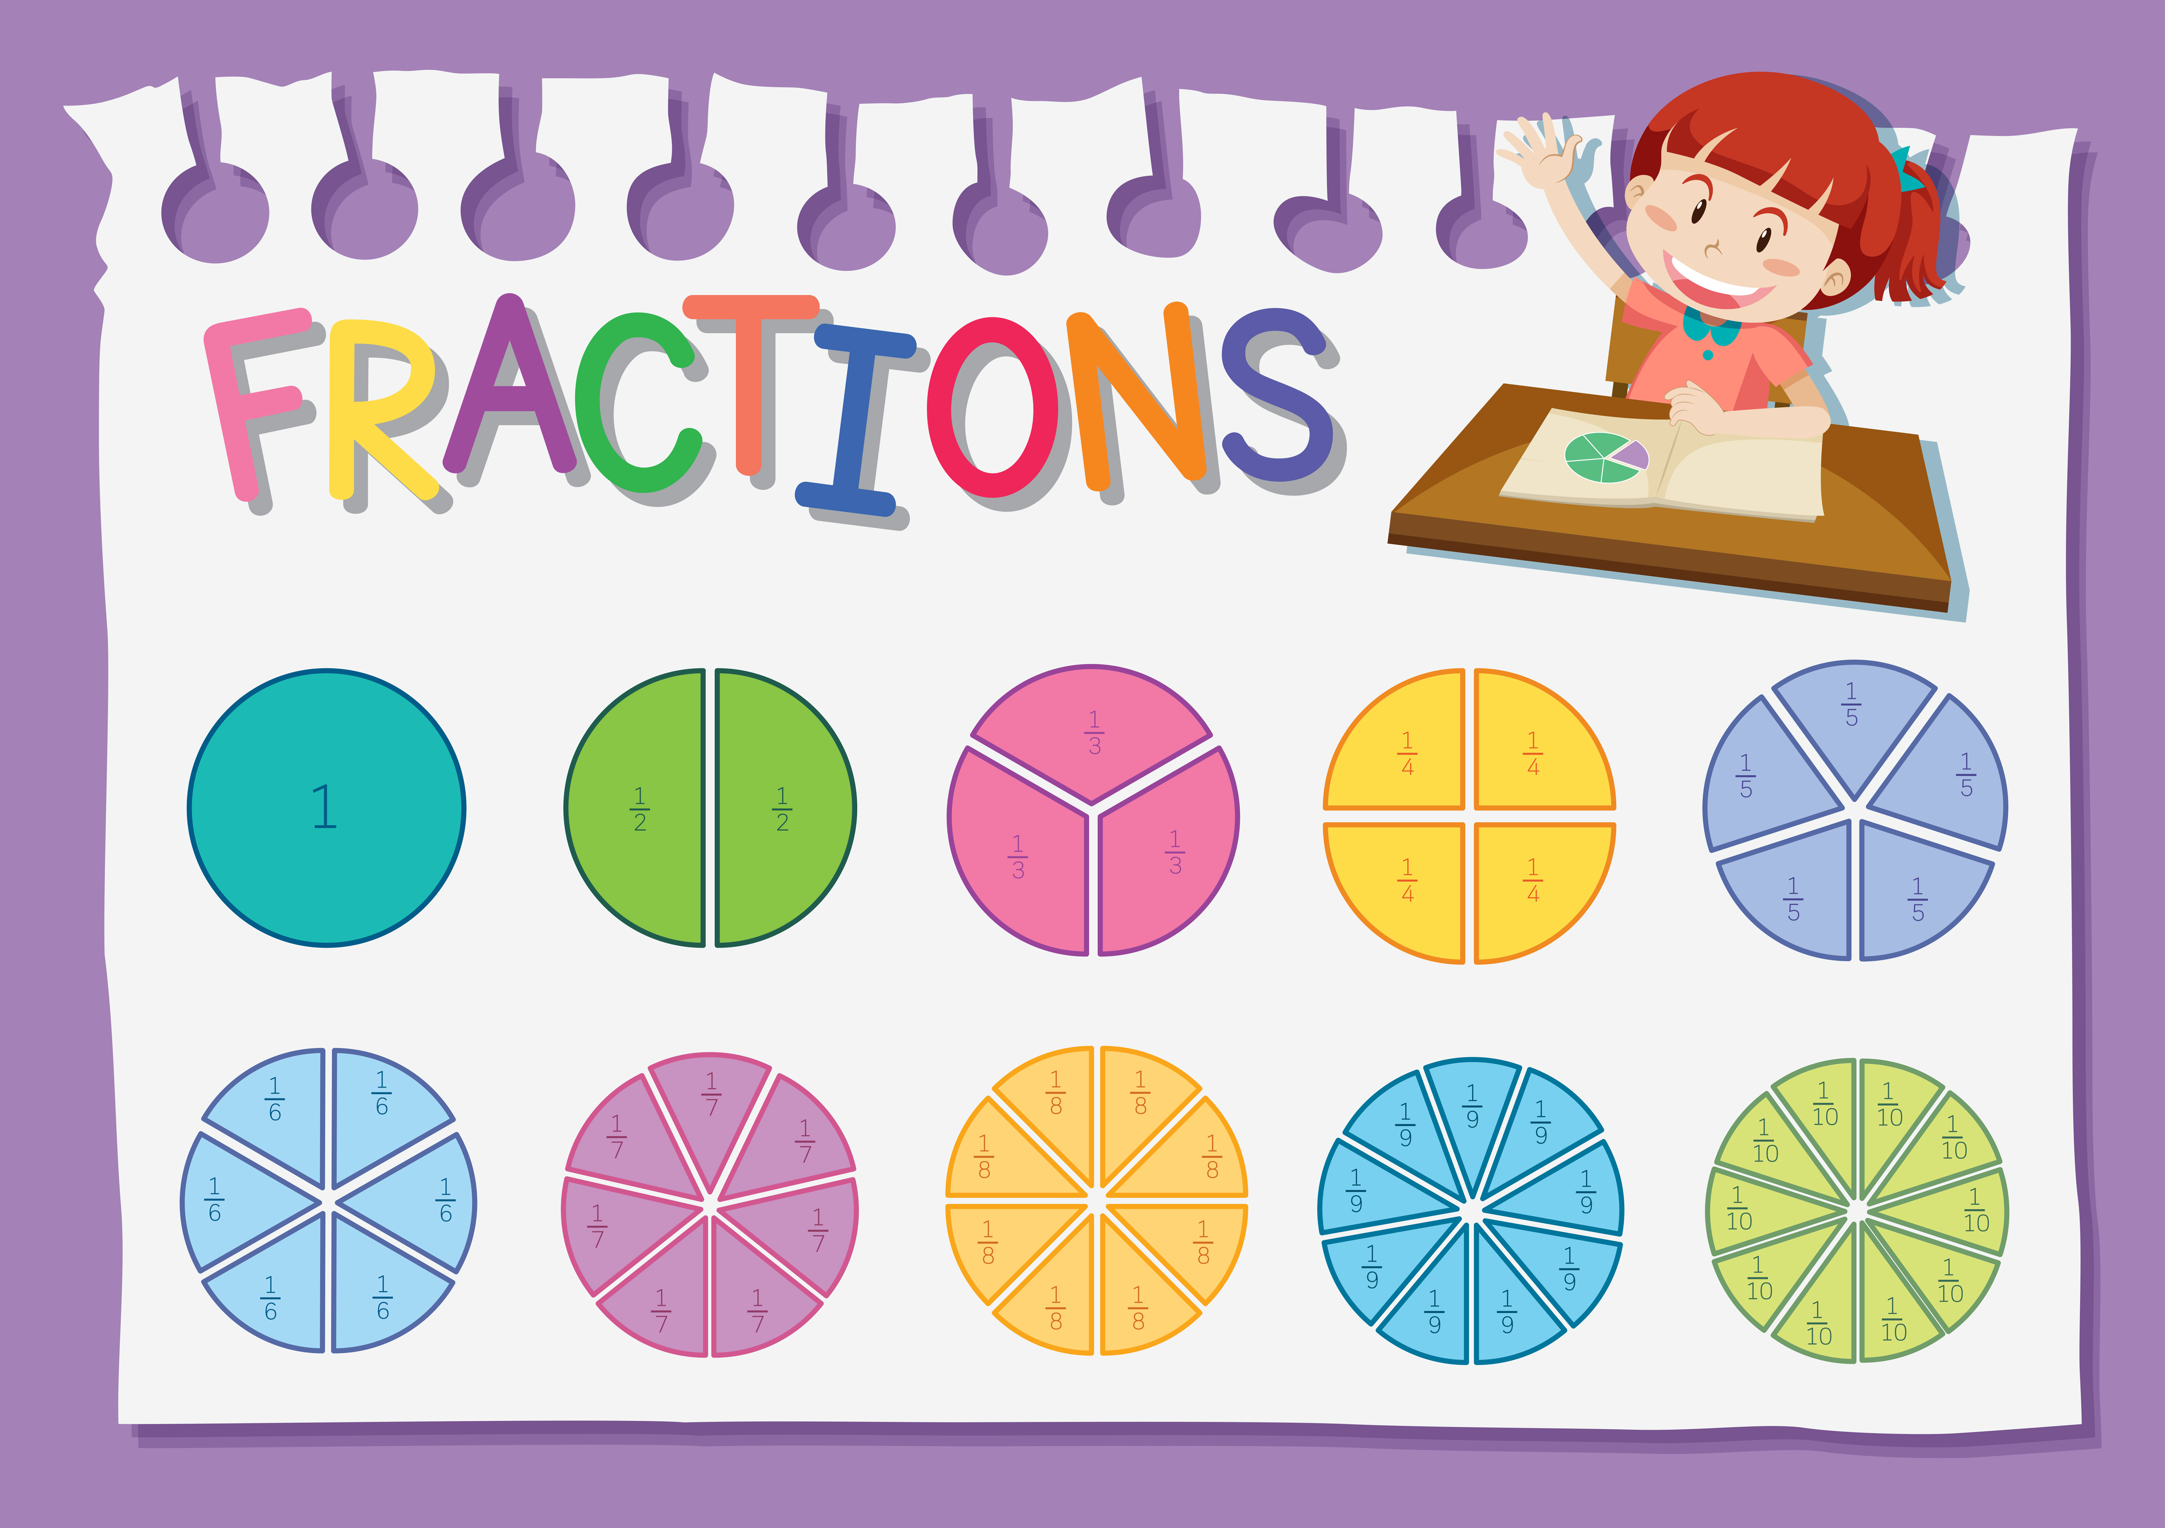

More about our topic…
This is an exciting topic where we will learn about the developments of travel throughout history. Children will develop an understanding and appreciation of how these developments have impacted upon our society.
Pupils will compare different transports through history and compare them with transport day.
We will learn about fascinating events in history, including the moon landing and Neil Armstrong, the Wright Brothers first flight and the early steam locomotive - Stephenson’s Rocket. 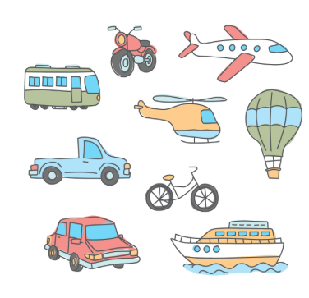
Pupils will use information to describe the past, and the differences between then and now.
We will use different sources of information, such as, books, pictures, eye-witness accounts, photographs and videos.
As well as this, our study will include the lives of many significant individuals who have contributed to national and international achievements.
Make sure you continue to keep an eye on our web page to see the fantastic learning taking place!
English
In English, we will be improving our grammar, language and ability to write for different purposes through our topic. Some of the exciting writing opportunities this term includes imaginative stories, information texts, recounts and sense poetry.

Our class book for this term will be
The Train to Impossible Places
by PG Bell (Year 2) and
Huxley and Flapjack to the rescue!
(Year 1.)
We can’t wait to read about all the
exciting adventures!

Reading for pleasure and enjoyment will lie at the heart of our English curriculum. Children will be involved in using a wide range of texts, linked to topic. They will take part in group discussions and will be encouraged to share their own views and reading interests. Through discussion and questioning comprehension skills will be developed, enabling children to increase understanding and appreciation of literature. Opportunities within all areas of the curriculum will be made available for children to develop their spoken language through discussion, drama and presentations.

Year 1 and 2
Planes, Trains and Automobiles

