
Read all about it
Me and my village (Autumn 1) and Fireworks and Fairytales (Autumn 2)
During their time in Reception, the children will have the opportunity to flow between both classrooms and explore all outside areas. They will have their own class bases, but continuous provision will happen as one unit, allowing sharing of resources, expertise and providing extra opportunities for developing social skills and understanding.
Me and my village We will be learning about ourselves and others. Together we will look at similarities and differences, families and those that are special to us. We will explore our local surroundings and discuss familiar sights around the village.
Fireworks and Fairytales As the weather starts to get colder, we will explore a variety of celebrations such as Diwali, Bonfire night, Hannukah and Christmas. We will begin to explore traditional tales and discuss favourite stories as well as developing our oral storytelling skills.
English
We will be learning routines for Read Write Inc phonics and starting to learn sounds in class. We will look at the letters that are used to represent the sounds and begin to form them when writing.
Reading for pleasure and enjoyment will lie at the heart of our English curriculum so the children will bring home a book of their choice from our bookshelf. We do not expect them to read it to you. It is for you to share with them.
We will be developing the children’s ability to listen attentively and respond to what they have heard with relevant comments, questions and actions. We have some lovely books to share with the children including The tiger Who Came to Tea, Can’t You Sleep Little Bear and Stick Man. The children will take part in group discussions and will be encouraged to share their own views. We will be re-telling, inventing and adapting stories and creating story maps. The children will also be learning a variety of topic related rhymes, poems and songs. We will be learning lots of new vocabulary.
Maths
In the autumn term we will be focusing on developing a deep understanding of numbers to 5 including formation, patterns and counting.
Important information for starting school:
Label everything! Trying to sort out 30 identical jumpers at the end of the day is incredibly difficult. If
clothes are labelled it will make
so much easier. – Thank you
Please bring in a labelled pair of wellies
Forest schools is on a Friday afternoon – Please send your child to school in their school uniform but
ensure they have suitable clothing
to change into (wellington boots, trousers/top that can get mucky)
We will be outside in all weathers so dress for the weather of the day
Please pack a change of underwear every day (Just in case) as children get very busy and excited often forgetting to go to the toilet
until it is too late.
Remember to regularly check the school website/tapestry for updates
Meet our team:
Ladybirds | Dragonflies
 | 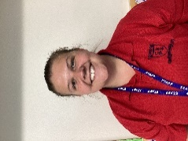
Mr Smith  EYFS Lead/ Class Teacher | Miss Rolfe  Class Teacher
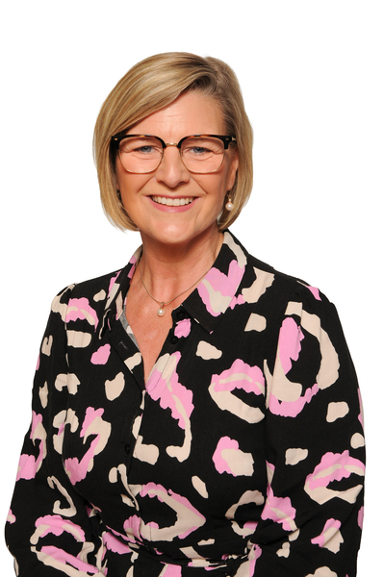 | 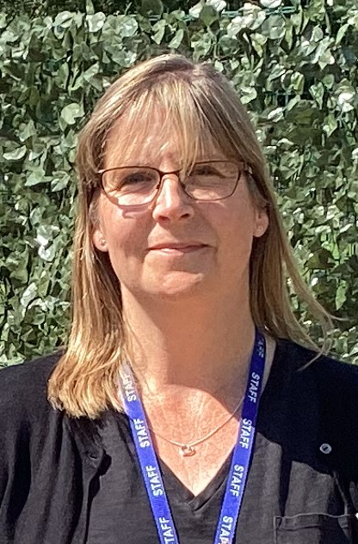
Mrs Dougill  Cover on Tuesdays | Mrs Tubb  Cover on Tuesdays
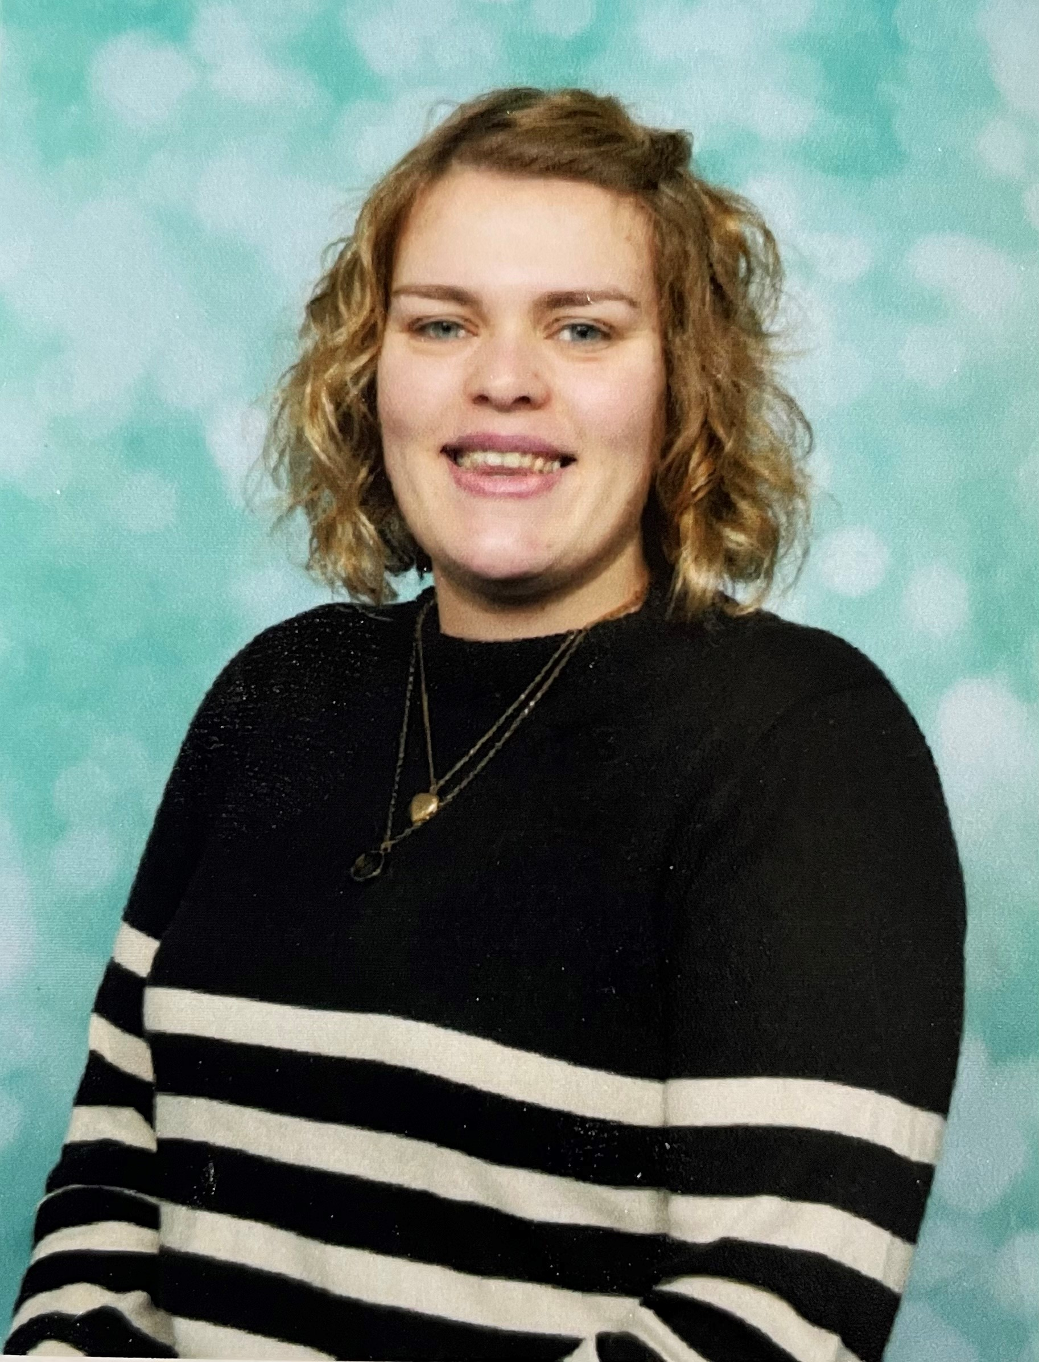 | 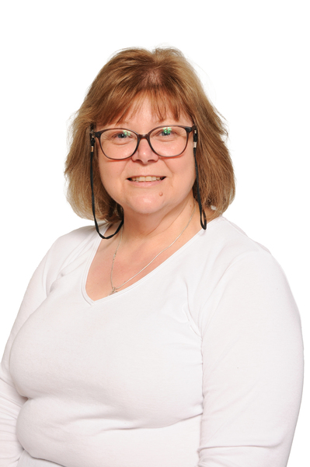
Miss Sandall  Teaching Assistant | Mrs Glass  Teaching Assistant
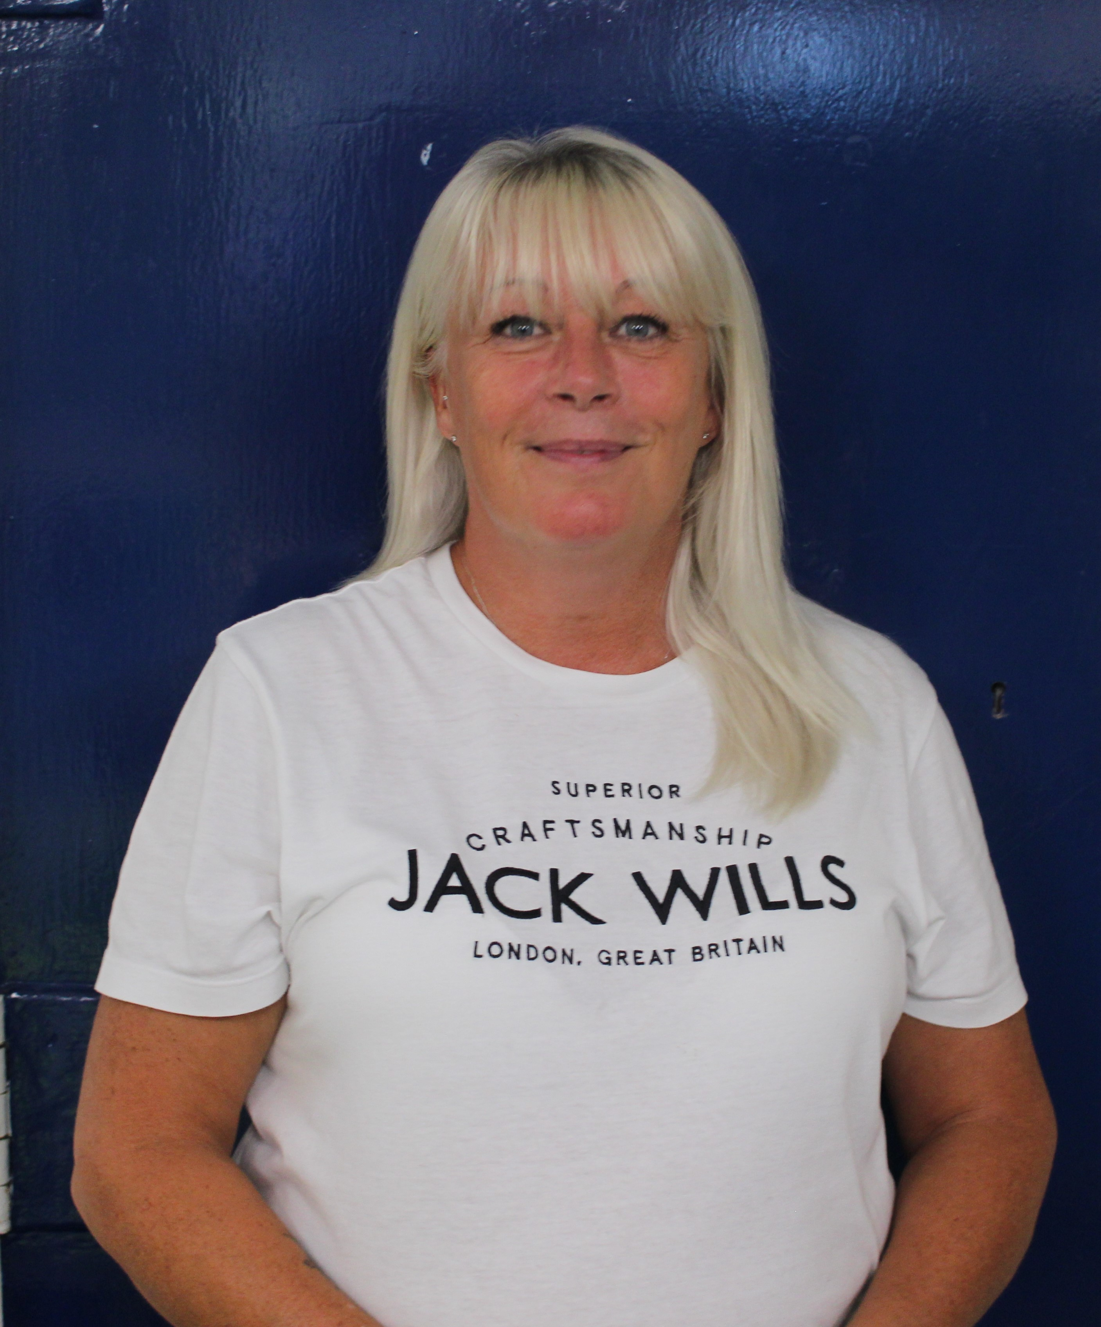
Mrs Wadsworth
1:1 Support Assistant

Reception
Autumn Term 2025

