
Reminders
- Label everything! Trying to sort out identical jumpers at the end of the day is incredibly difficult. If clothes are labelled it will make it so much easier.
- PE day is a Tuesday and Forest schools is a Friday
- Please pack a change of underwear every day as children get very busy and excited often, forgetting to go to the toilet until it is too late. (Please remember to return any school spares)
- Remember to regularly check the school website/tapestry for updates.

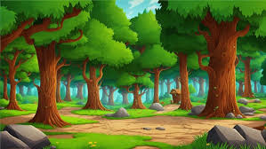
The Great Outdoors
After Christmas we will be beginning to explore anything and everything in the outside world focusing in particular on seasonal change. We will investigate the signs of Winter during the colder months of January and February, looking at how different materials are affected by temperature such as water. We will begin to look at how different animals survive in winter, looking at habitats and different foods. We will compare the climate of our own environment with those around the world, using the immersive suite to experience various habitats such as the jungle, under the sea, mountains and even a trip to Antarctica!
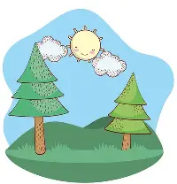
Come Outside
As the weather warms up after February half term, we will be spending more and more time outside. We will investigate plants and animals as well as seasonal change. We will look at the life cycles of some animals and how plants grow. We will have a go at planting our own plants and taking care of them. We will read some exciting stories linked to this topic such as Jack and the Beanstalk.

The children settled into school extremely well. They are taking every day in their stride. The children really enjoyed our topics in the Autumn term and particularly enjoyed learning about new stories and getting into the immersive suite.
English – In English we will continue to develop our skills in Read Write Inc Phonics lessons, focusing on blending sounds to read words and using Fred Talk to support writing simple words and phrases using the sounds that we know. We will be exploring the following exciting texts: The Oak Tree, Where the Wild Things Are, The Journey, The Gruffalo, What the Ladybirds Hears and Jack and the Beanstalk. We will be creating story maps, labelling pictures, ordering scenes from stories and beginning to write with a purpose such as when creating our own descriptions. We will continue our work on forming letters correctly.
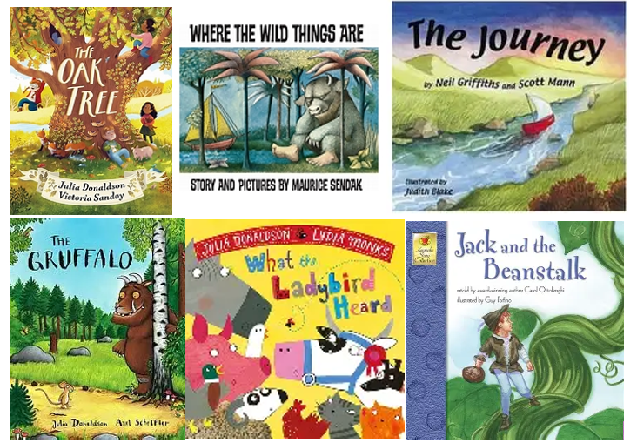

Maths - In the Spring Term we will be focusing on developing a deep understanding of numbers beyond 5 up to 10. We will begin to look at comparing these numbers and investigating different ways that we can make 10. We will start to look at mass, length, capacity and time and begin to compare these using everyday and simple mathematical language. We will extend our knowledge of shape to begin to investigate 3D shapes. We will continue to investigate and explore patterns.
EYFS Reception
Spring Term 2026
Keen to Be Green
The Great Outdoors Come Outside
Spring 1 Spring 2

